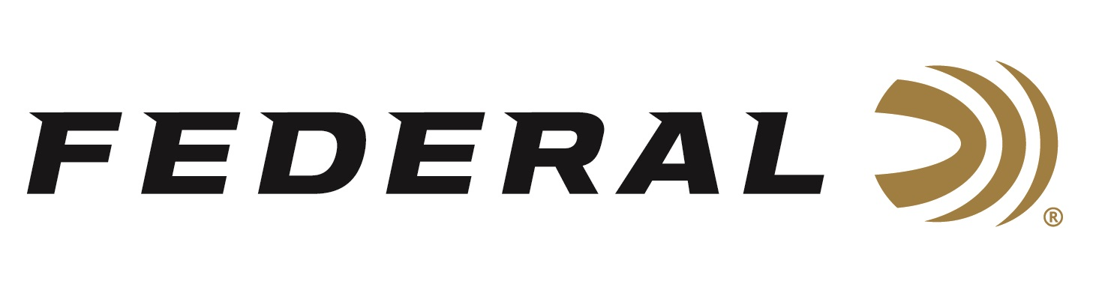

FOR IMMEDIATE RELEASE

Federal Ammunition sponsored shooters claim World ISSF Skeet Championships

ANOKA, Minnesota – August 21, 2023 – Federal Ammunition congratulates sponsored shooters Vincent Hancock and Austen Smith on capturing the ISSF Mixed Team Skeet World Championship in Baku, Azerbaijan on Sunday, August 20, 2023.

3-time Olympic Champion Vincent Hancock paired with fellow Olympian Austen Smith defeated a team from the Ukraine in the Mixed Team Skeet finals. The dynamic duo is having a great summer teamed together as they earned a World Cup Mixed Team Skeet gold medal in Lonato, Italy back in July. “Another great international performance by Vincent and Austen,” says Jason Nash, Federal’s Vice President of Marketing. “These two make a great pairing and Federal Ammunition is proud of their summer of successes.”

Hancock and Smith also helped the United States bring home team titles in Skeet Men’s Team and Skeet Women’s Team events. Smith, along with Dania Vizzi and Samantha Simonton, defeated Italy to claim the top podium spot. On the men’s side, Hancock, anchoring the American team, along with Christian Elliot and Dustan Taylor defeated Team Greece for the World Title.

Both shooters competed in the individual championships, but both fell just a few targets short of placing. Hancock finished fourth in the Men’s Skeet and Smith finished fifth in the Women’s Skeet competition. “I was first going into the final, but a few misses early landed me 4th in the individual competition. Thankfully, I was able to compete very well in the other two events and am bringing home two Gold Medals,” says Vincent Hancock, a 3-time Olympic Men’s Skeet Champion.

Federal is the number one choice for shotgun shells and manufactures product in America for all competitive and recreational disciplines. See the full lineup, including the latest High Over All, at www.federalpremium.com.

Federal ammunition can be found at dealers nationwide. For more information on all products from Federal or to shop online, visit www.federalpremium.com.

Photo credit: USA Shooting

Press Release Contact: JJ Reich
Senior Manager – Press Relations
E-mail: VistaPressroom@VistaOutdoor.com

About Federal Ammunition
Federal, headquartered in Anoka, MN, is a brand of Vista Outdoor Inc., an outdoor sports and recreation company. From humble beginnings nestled among the lakes and woods of Minnesota, Federal Ammunition has evolved into one of the world's largest producers of sporting ammunition. Beginning in 1922, founding president, Charles L. Horn, paved the way for our success. Today, Federal carries on Horn's vision for quality products and service with the next generation of outdoorsmen and women. We maintain our position as experts in the science of ammunition production. Every day we manufacture products to enhance our customers' shooting experience while partnering with the conservation organizations that protect and support our outdoor heritage. We offer thousands of options in our Federal Premium and Federal® lines-it's what makes us the most complete ammunition company in the business and provides our customers with a choice no matter their pursuit.

